

**PR User Manual**

**User Manual for Purchase Requisition in SAP**



**Contents**

**What is Purchase Requisition?** 3

**Types of Purchase Requisition:** 3

**Opening Purchase Requisition Screen:** 4

**Prerequisites for Purchase Requisition** 5

**Header Tab** 6

**Item Overview Tab** 6

**Maintenance Purchase Requisition** 10

# **What is Purchase Requisition?**

In any business, multiple departments need materials from time to time—from basic office supplies to raw materials, equipment, and services.

A purchase requisition is an internal document used by an organisation to purchase goods or services. These purchases may be for business operations (such as office supplies), inventory, assets or manufacturing inputs.

The purchase requisition is then subjected to an internal approval process, where it is verified by the line manager of the requestor’s department. The line manager’s duty is to check the legitimacy of the purchase and also ensure that the value of the purchase does not exceed the department’s allotted spending limit.

From here, the requisition form is routed to the inventory department, which checks it against the company’s existing stock in other plant or location. If the requested materials are not already in stock, they forward the request to the purchasing department.

# **Types of Purchase Requisition:**

* **Maintenance Purchase Requisition for material or services:** Maintenance requisitions are requests that are created to notify a manager or planner that an asset might require a maintenance or repairing job.
* **Service Purchase Requisition:** Service requisition is the approvable document created by the commercial team of a business organisation to submit a request to procure service items.
* **Assets Purchase Requisition:** Asset Requisition serves as a request that departments can generate to communicate their need for a particular asset or equipment.
* **Project Purchase Requisition for material or services:** Project requisition is used to request resources for a specific project, such as materials or equipment, etc.
* **Cost Accounting Purchase Requisition:** Cost Accounting requisition is a request to order a material that is not subject to value-based inventory management and post its value directly to consumption
* **Scheduling Purchase Requisition:** Scheduling requisition is a request to procure materials which is to be delivered in multiple delivery dates or batches, as per the business requirement.
* **Sub-Contracting Purchase Requisition:** Subcontracting requisition lists the finished material that is to be procured in a subcontract item. Against each subcontracted item the system copies the material components that are to be provided to the vendor from the bill of material (BOM) or can be entered manually.
* **Stock Transfer Purchase Requisition:** Stock Transfer requisition is a request to procure material from a different plant within the same company or different company within the same company group.
* **Internal Order Purchase Requisition for CWIP (Capital Work In Progress**): Internal order requisitions are request to generate a requirement for internal orders which are normally used to plan, collect, settle and manage the costs of internal jobs and tasks. Mostly used for Capital Work in Progress (CWIP) expenses.

# **Opening Purchase Requisition Screen:**

Purchase Requisition screen can be opened by the following steps:

* Path to Purchase Requisition: SAP Menu 🡪 Logistics 🡪 Materials Management 🡪 Purchasing 🡪 Purchase Requisition 🡪 Create
* Executing T-Code: **ME51N**
* For Changing a Purchase Requisition: **ME52N**
* For Displaying a Purchase Requisition: **ME53N**

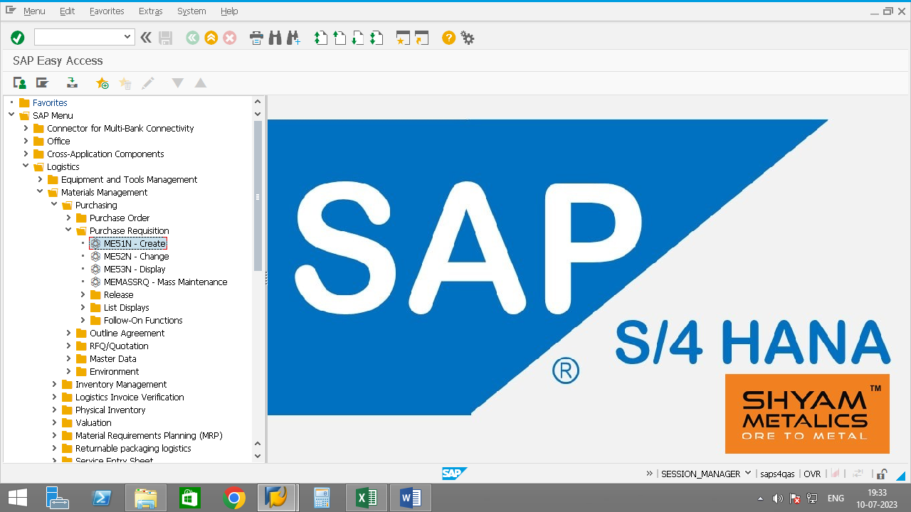

The Purchase Requisition screen will open as below:

The create purchase requisition screen has three different tabs namely, **Header Tab**, **Item Overview Tab**, **Item Details Tab**

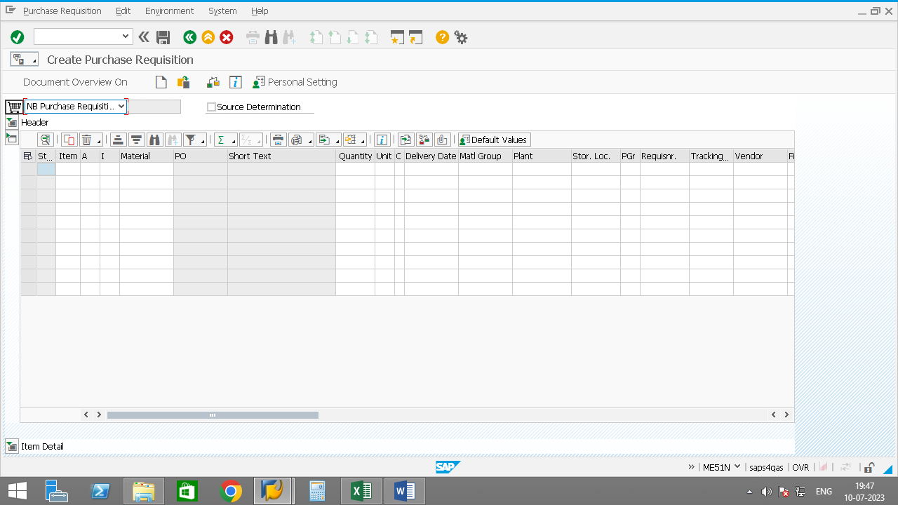

* 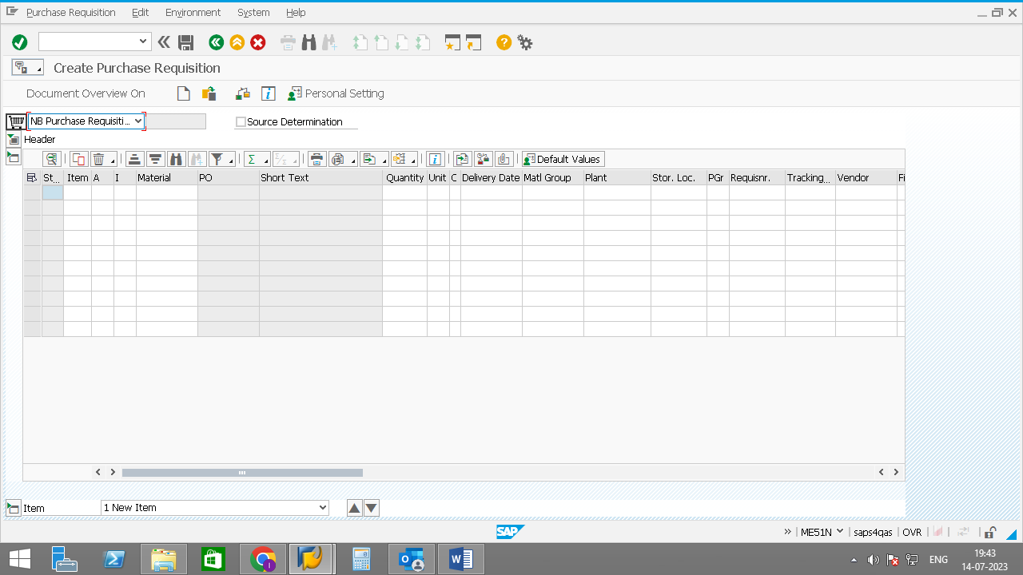The tabs can be collapsed or expanded using button.
* The **header tab** consists of Header note text box in which the user can enter text regarding the requisition created, or terms and conditions regarding the purchase requisition.
* In **Item overview tab** the user needs to enter the item details as per the requisition, namely account assignment, item category, material code, quantity, unit of measurement, delivery date, material group, receiving plant, storage location, purchasing group, requisitioner and tracking no.
* In **item details tab** shows the details regarding the data entered by the user in item details tab.

# **Prerequisites for Purchase Requisition**

* User needs to check if the stock is available or not, if the stock is below safety stock level or not or if the stock is available in some other plant under the same Company Group.
* Material Code
* Quantity of material to be ordered.
* Asset Code for Assets PR. Asset code can be displayed by AS03, if the asset code is not created the user needs to create new asset code through AS01 and can be changed by AS02.
* WBS Element for Project PR. Can be created or displayed from CJ20N.
* Network Number for Project Network PR. Network Number can be displayed by CN23, if the network number is not created as per requirement the user needs to create new network number through CN21 and can be changed by CN22.
* Cost Centre for Cost Accounting PR.
* G/L account
* Internal Order No. or Maintenance Order No. for Internal Order PR.
* Plant Code of Supplying Plant for Stock Transfer PR.
* Material Code of Raw Materials to be used in Bill of Material (BOM) for Sub-Contracting PR (if BOM is not maintained).
* Service Number for Service PR. Service Number can be displayed by AC03, if the Service Number is not created the user needs to create new asset code through AC01 and can be changed by AC02.
* Authorization of ME51N for Creation of Purchase Requisition.
* Authorization of ME52N for Changing a Purchase Requisition.
* Authorization of Concerned Plant for which the user needs to create a Purchase Requisition.

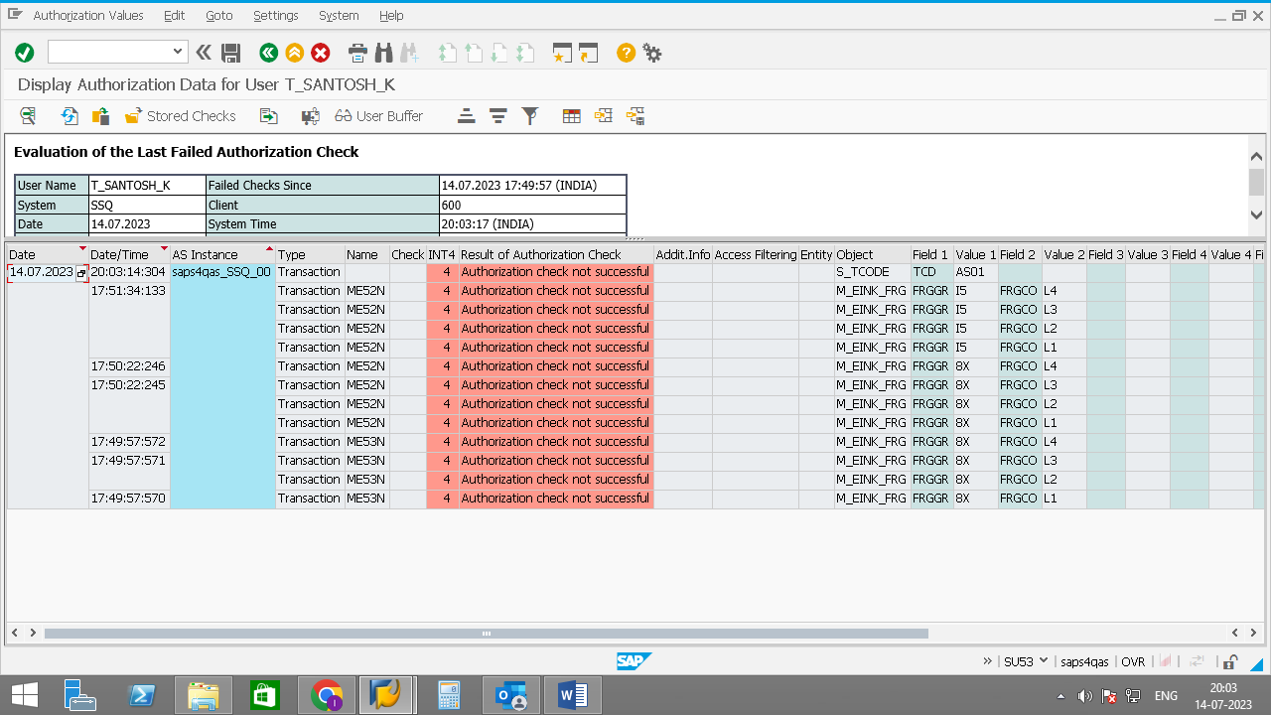**Special Note:** If authorization is not available for a particular object, execute T-Code: SU53 and share the screenshot with the SAP Technical Support for providing the authorization for the same. (Demo Screenshot of SU53 attached below).

# **Header Tab**

The header tab consists of header note text box in which the user needs to enter the details regarding the requisition, the terms and conditions valid for the requisition, or certain conditions required for the requisition, which needs to be conveyed to the approving department.

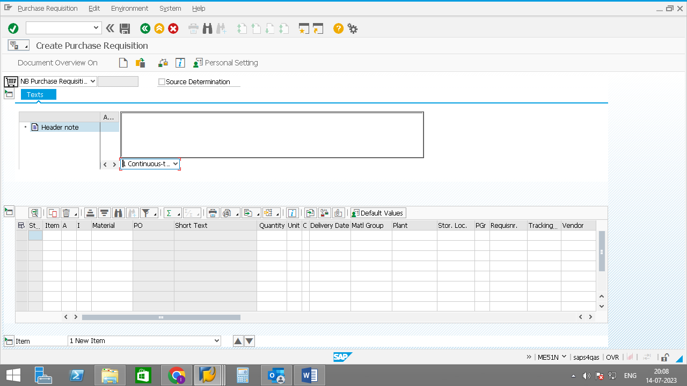

# **Item Overview Tab**

The Item Overview tab is the second tab in create purchase requisition screen and consists of the details of items of which the requisition is to be raised. In Item Overview tab the various fields are as below, the user can view help regarding the field by pressing F4 button:

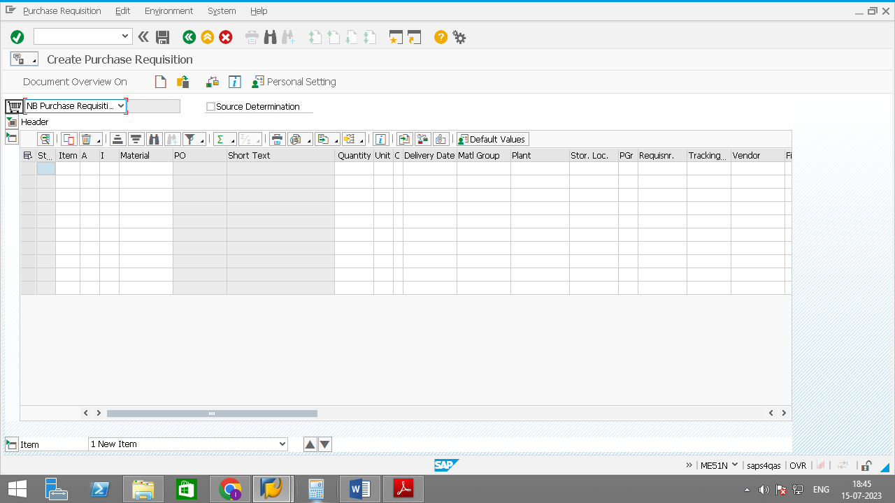

* 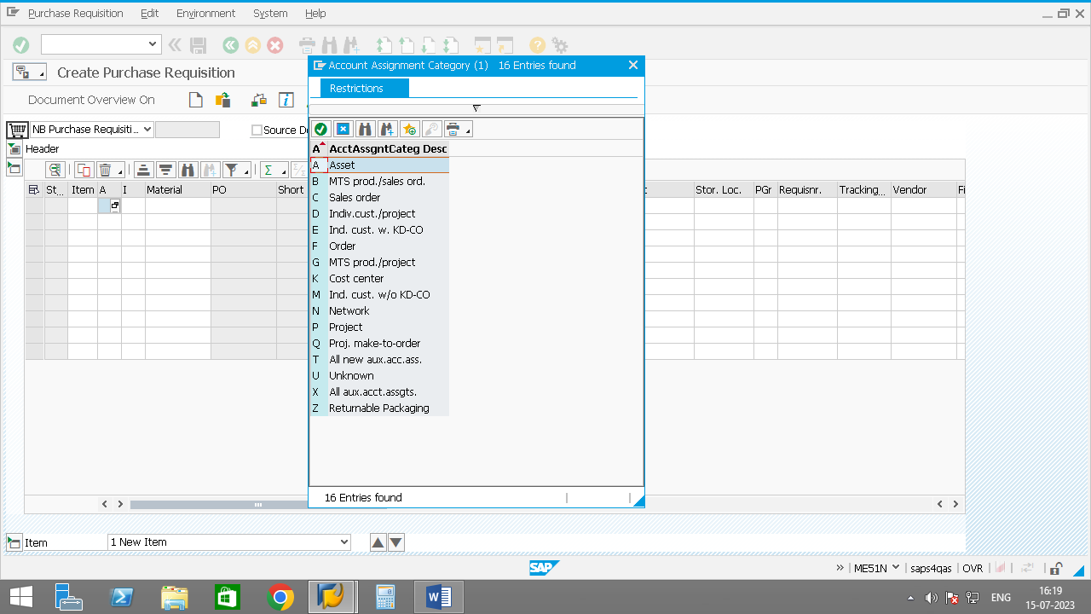**Account Assignment:** In account assignment the user needs to enter the account assignment to which the material will be accounted or will be inventorized. In standard SAP practice the following account assignments are used–

**‘A’ -** If the material is an asset and asset accounting is to be

done for the same user needs to enter ‘**A’** in Account

Assignment. **Used for Assets PR.**

**‘F’ -** If the material or service is accounted for internal

Order then the user needs to enter ‘**F’** in account

assignment. **Used for Internal Order PR.**

**‘K’ -** If the material or service is to be shown as an expense

directly and not inventorised then the user needs to enter

**K** in account assignment. **Used for Cost Accounting PR.**

**‘N’** **-** If the material or service is for expenses related to

Network expenses of any project the user needs to enter N in

Account assignment. **Used for Network PR for project.**

**‘P’ -** If material is related to a particular Project and to be

shown as direct consumptionthen the user needs to enter P

in account assignment. **Used for Project PR (for consumption)**

**‘Q’ -** If material is related to a particular Project and is to be

shown in inventory as **special stock** and to be used

particularly in that project then the user needs to enter Q in

account assignment. **Used for Project PR (for inventory)**

* 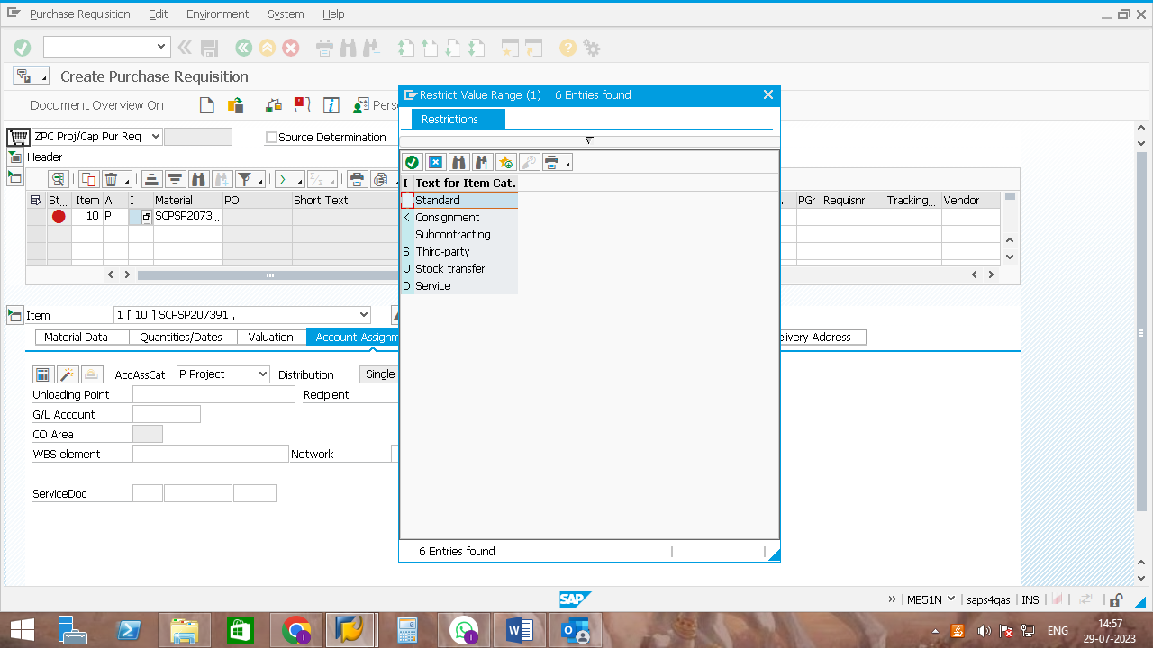**Item Category:** Item category is used to determine the characteristics of an item. In standard SAP practice the following account assignments are used –

**‘ ‘ -** For standard material the item category is to left blank.

**‘K’ -** For consignment material, the item category to be

entered is K.

**‘L’ -** For subcontracting or job work material, the item

category to be entered is L.

**‘U’ -** For stock transfer material, the item category to be entered is U.

**‘D’** – For Services, the item category to be entered is D.

# **Maintenance Purchase Requisition**

Maintenance requisitions are requests that are created to notify a manager or planner that an asset might require a maintenance or repair job.